**

**Table of Contents**

**Executive Summary 3**

**1. Message from NSF: Transforming Geosciences through EarthCube 4**

**2. EarthCube Vision and Mission 5**

**3. A Timeline for EarthCube 6**

**4. End User Workshops: Requirements from Scientists (2012-2014) 8**

**5. EarthCube Funded Projects (2013 and 2016 awards) 9**

**5.1 Research Coordination Networks: Engaging Science Communities 10**

**5.2 Building Blocks: Exploring Solutions and Demonstrating Utility 12**

**5.3 Conceptual Designs: Initial Planning for Enterprise Architecture 14**

**5.4 Test Governance: Formal Mechanisms to Involve the Community 15**

**6. Getting Involved 16**

**6.1 The Science Committee 17**

**6.2 The Technical and Architecture Committee 17**

**6.3 The Engagement Team 17**

**6.4 The Liaison Team 17**

**6.5 The Council of Data Facilities 18**

**6.6 The Leadership Council 19**

**6.7 Other Opportunities 20**

**Executive Summary**

EarthCube began in 2011 as joint initiative between the National Science Foundation (NSF) Directorate for Geosciences (GEO) and the Division of Advanced Cyberinfrastructure (ACI). This evolving, dynamic community effort is not only a new way for the NSF to partner with the scientific community, but also a challenge for the many academic, agency and industry stakeholders in the geo-, cyberinfrastructure, computer and social sciences to create new capabilities for sharing data and knowledge and conducting research.

EarthCube’s goal is to enable geoscientists to address the challenges of understanding and predicting a complex and evolving Earth system by fostering a community-governed effort to develop a common cyberinfrastructure to collect, access, analyze, share and visualize all forms of data and resources, using advanced technological and computational capabilities. EarthCube’s vision is to create a dynamic, community-driven cyberinfrastructure that will support standards for interoperability, infuse advanced technologies to improve and facilitate interdisciplinary research, and help educate scientists in the emerging practices of digital scholarship, data and software stewardship, and open science.

Achieving these objectives requires a long-term effort, which the NSF anticipates supporting until at least 2022. It also requires a community desire to identify common solutions and best practices, adapt and respond to change as cyberinfrastructure evolves, and adopt new technologies and approaches.

Between 2012 and 2014, the NSF funded twenty-four EarthCube domain end-user workshops. Their purpose was to allow the constituent geoscience communities to articulate their cyberinfrastructure needs and science goals, particularly in relation to the accessibility of data and information both within their disciplines and from other fields. In 2013 and 2014, the NSF funded several dozen projects focused on software component development, architecture design, efforts to advance community-building, and governance.

An important result of these activities was the development of an initial EarthCube governance through several community events. This governance structure was put in place in the Fall of 2014 and will be operating in the next few months to develop processes to coordinate community input and ongoing work. EarthCube’s Leadership Council oversees the activities of the five components of EarthCube governance: the Science Committee, the Technology and Architecture Committee, the Council of Data Facilities, the Liaison Team, and the Engagement Team. The Council is comprised of community-elected representatives drawn from each of these components, and at-large members of the Atmosphere/Space; Oceans, Earth Sciences, Polar and Cyberinfrastructure communities.

Above all, EarthCube is an evolving, dynamic community effort that actively seeks to engage individuals and partners from across the geosciences and cyberinfrastructure. The more scientists and technologists are engaged in future EarthCube activities, the more EarthCube can and will achieve.

**1. Message from NSF: Transforming Geosciences through EarthCube**

*Since the beginning of EarthCube in 2011, we at the National Science Foundation have appreciated anew the frontier science challenges undertaken by the academic geosciences community and their partners. We know the community will seek even greater challenges in the future to understand the fundamental processes of the Earth system, within the atmospheric, earth, geospace, ocean and polar sciences and across those boundaries. EarthCube is intended to support this endeavor and transform the conduct of geosciences research by creating a more productive research environment, with new capabilities for sharing data and knowledge by and beyond the geosciences.*

*As a joint effort of the NSF Directorate for Geosciences and the Division of Advanced Cyberinfrastructure, EarthCube is a new approach for NSF to partner with the scientific community. It envisions an iterative process for creating community-driven and governed cyberinfrastructure, and requires collaboration among the many stakeholders in the geosciences, cyberinfrastructure and computer sciences, social sciences, as well as agency and international partners that share these goals. It is critical to this partnership to have a staged and deliberate approach to EarthCube, allowing time for broad and open involvement, as well as assessment and responsiveness from both NSF and the community.*

*We are now in a new phase for EarthCube where the responsibilities for and drivers of EarthCube come from the scientific community. NSF welcomes this transition and the wide adoption of EarthCube’s vision and process, as reflected by this document. It presents the community’s view of where we have been and how EarthCube will be formed through collaborative activities, from the strategic visioning of EarthCube to conceiving and standing up a functioning community governance through Test Enterprise Governance; from the vital input and guidance of the geosciences domains workshops and Research Coordination Networks to the initial elements of EarthCube found within the Building Blocks and Conceptual Designs.*

*We know this will be a long-term effort with many changes over time as cyberinfrastructure evolves to accommodate changing user needs and emerging technologies and services. EarthCube will be supported by the existing foundation of cyberinfrastructure investments, including databases, software services and community facilities that have been created by the geosciences and cyberinfrastructure communities over the past two decades. Success in serving the entire geosciences community will depend in part on identification of common solutions and best practices, and strategic adoption of new technologies and approaches. It will also depend on the continued participation and work of the community, and we are grateful for the many contributions that have already been made on behalf of EarthCube.*

*NSF commends the community for their whole-hearted spirit of collaboration, the bright vision they see for geosciences in the future and our ability to work in partnership to achieve this vision. We look forward to working closely with the entire EarthCube community in the years to come.*

**Eva Zanzerkia**

Program Director, EarthCube

Directorate for Geosciences

National Science Foundation

**2. EarthCube Vision and Mission**

**EarthCube’s long-term vision is**

a community-driven dynamic cyberinfrastructure that will support

standards for interoperability,

infuse advanced technologies to improve and facilitate interdisciplinary research, and

help educate scientists in the emerging practices of digital scholarship, data and software stewardship, and open science.

**EarthCube’s mission is**

to enable geoscientists to address the challenges of understanding and predicting a complex and evolving Earth system

by fostering a community-governed effort to develop a common cyberinfrastructure

to collect, access, analyze, share and visualize all forms of data and resources,

using advanced technological and computational capabilities.

*(From the EarthCube Leadership Council, December 2014)*

**3. A Timeline for EarthCube**

EarthCube was established in 2011 via a collaborative partnership between NSF’s Directorate for Geosciences (GEO) and the Division of Advanced Cyberinfrastructure (ACI). An NSF Dear Colleague Letter[1] was released in June 2011 announcing the partnership and initial goals for EarthCube. Several webinars followed, and an additional document, EarthCube Guidance for the Community[2], gave more detailed guidance. These announcements launched the first conversations about the future of EarthCube. Over the next two years, a series of webinars, community meetings (Charrettes), and White Paper and Roadmap solicitations provided a forum for potential participants to propose what EarthCube should look like in terms of science requirements, technology solutions, designs, and governance.[3]

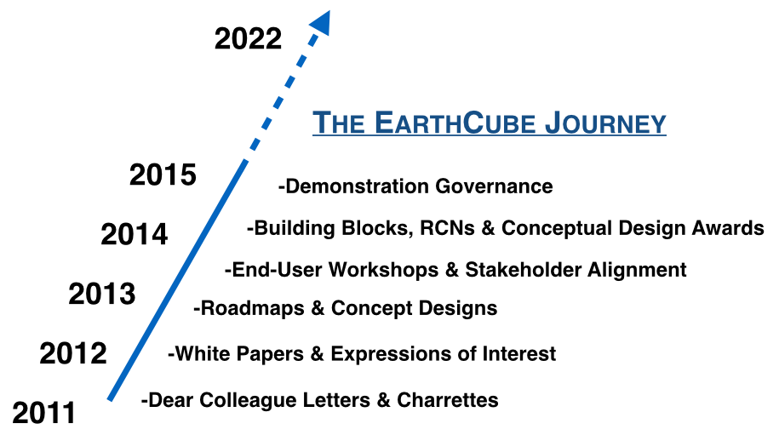

Between March and August 2012, each of the Community Groups and Concept Teams was tasked with preparing Roadmaps to show how to move their area of EarthCube forward. These roadmaps were the culmination of months of research, community outreach, and deliberations in virtual and physical meetings, and they identified the initial stakeholders and cyberinfrastructure components. Collectively they served to provide NSF and other interested parties with a cross spectrum of ideas and concepts from the Earth, computer, information science and other stakeholder communities regarding key elements needed to build EarthCube. They were presented to NSF and the EarthCube community at the second EarthCube charrette.

The second EarthCube charrette took place in Roslyn, VA, in June 2012. This event engaged 190 physical and 60 remote attendees and focused on moving EarthCube forward. A goal of the charrette was to review and integrate the Community Group and Concept Team draft roadmaps, to forge a common vision, and create a cohesive set of milestones to move EarthCube forward. Activities and discussions focused on the identification of common themes, challenges, and synergies; that could be merged into one common roadmap for EarthCube.

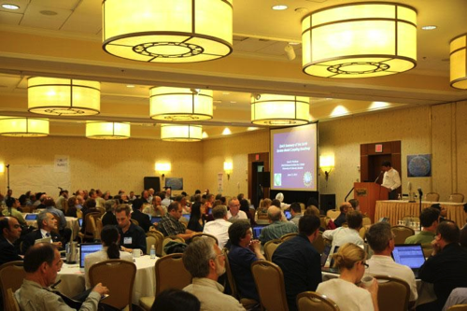

Beginning in summer 2012, NSF funded a series of 24 EarthCube domain end-user workshops. These workshops targeted a broad spectrum of Earth, atmosphere, ocean, and allied senior, mid- and early-career scientists. The purpose of these workshops was to allow the constituent geoscience communities to articulate their cyberinfrastructure needs and science goals, particularly in relation to the accessibility of data and information both within their disciplines and from other fields.

Meetings of the EarthCube Community Groups and Concept Award Teams Principal Investigators were held in June and October 2012. The first meeting fostered the discussions and roadmap integration efforts, which began at the June 2012 charrette, and generated ideas for use cases, reference architecture, governance and timelines. The follow-up meeting furthered integration of the roadmaps, thereby developing a more cohesive vision of how to move EarthCube forward. Significant steps have been made towards achieving this goal, and a comprehensive technical roadmap for EarthCube is being assembled.

In September 2013, the NSF, marking a new phase for EarthCube, announced $14.5 million in funding for initial software components development for EarthCube (‘Building Blocks'), projects to develop broad architecture design white papers (‘Conceptual Designs’), and Research Coordination Networks (RCNs) to advance community- building exemplars in several domain science communities, and a project to develop and test a prototype community governance framework. NSF support for EarthCube continued with the announcement of another round of awards in September 2014.

To date, a great deal of collaborative work has been done to further the advancement of EarthCube, but the process is far from complete, and in the coming years the geoscience community will continue to build and expand upon the work already done.

**4. End User Workshops: Gathering Requirements from Scientists (2012-2014)**

NSF funded 24 EarthCube domain end-user workshops targeting a broad spectrum of Earth, atmosphere, ocean, and related senior, mid- and early career scientists. The purpose of these workshops was to allow geoscience communities to articulate and document their cyberinfrastructure needs with the object of improving data and information access within and outside their disciplines. An additional goal of these workshops was to gather information about the science-drivers and data utilities, and the requirements for user-interfaces, models, software, tools, etc. so that EarthCube can be designed to help geoscientists more easily do the science they want and would like to accomplish.

Outcomes of the domain workshops and other community engagement programs continue to actively shape EarthCube’s form and function. Additionally, the workshops served to introduce EarthCube to a broad spectrum of end-users, and encouraged them to think about how data-enabled science could help them achieve their scientific goals. This information is currently being analyzed by working groups and teams constituted under EarthCube’s Demonstration Governance Structure, with the object of determining how it can best be leveraged to enable and enhance the future development of EarthCube..

Included in the Executive Summaries for each of these workshops are statements about the community’s science vision and the challenges it faces, as well as the technical requirements needed to address them, and priorities and recommendations for action.

End user workshop reports and other materials are available from <http://www.earthcube.org/page/end-user-workshops>, including a compilation of workshop executive summaries.

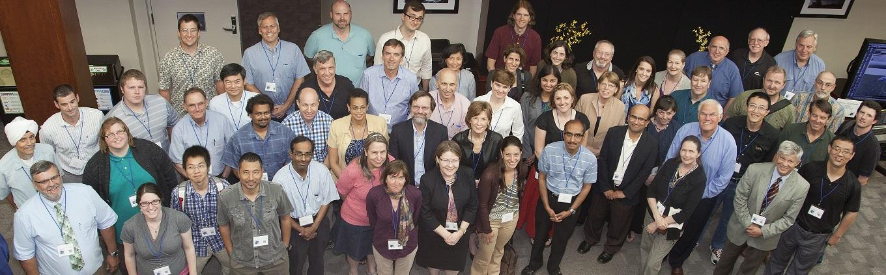

**http://www.earthcube.org/page/end-user-workshops**

**End User Workshops**

Meetings of Young Researchers in Earth Science (MYRES) V: The Sedimentary Record of Landscape Dynamics, August 8, 2012, Salt Lake City, UT

Envisioning Success - A Workshop for Next Generation EarthCube Scholars and Scientists, October 16-17, 2012, Washington, DC

Structural Geology and Tectonics, October, 20-21 2012, Chicago, IL

EarthScope, October 29-30, 2012, Arizona State University, Tempe, AZ

Experimental Stratigraphy, December 11-12, 2012, Austin, TX

Shaping the Development of EarthCube to Enable Advances in Data Assimilation and Ensemble Prediction, December 17-18, 2012, Boulder, CO

Engaging the Critical Zone Community to Bridge Long Tail Science with Big Data, January 21-23, 2013, Newark, DE

Envisioning a Digital Crust for Simulating Continental Scale Subsurface Fluid Flow in Earth System Models, January 29-31, 2013, Fort Collins, CO

Cyberinfrastructure for Paleogeoscience, February 4-6, 2013, Minneapolis, MN

Education, March 4-5, 2013, La Jolla, CA

Petrology and Geochemistry, March 6-7, 2013, Washington, DC

Sedimentary Geology, March 25-26, 2013, Salt Lake City, UT

Modeling for the Geosciences, April 22-23, 2013, Boulder, CO

Integrating Inland Waters, Geochemistry Biogeochemistry and Fluvial Sedimentology Communities, April 24-26, 2013, Boulder, CO

Deep Seafloor Processes and Dynamics, June 5-7, 2013, Narragansett, RI

Integrating Real-time Data into the EarthCube Framework, June 17-18, 2013, Boulder, CO

Ocean 'Omics, August 21-23, 2013, Catalina Island, CA

Developing a Community Vision of Cyberinfrastructure Needs for Coral Reef Systems Science, September 18-19, 2013, Honolulu, HI, and October 23-24, 2013, Santa Barbara, CA

Bringing Geochronology into the EarthCube Framework, October 1-3, 2013, Madison, WI

Articulating Cyberinfrastructure Needs of the Ocean Ecosystem Dynamics Community, October 7-8, 2013, Woods Hole, MA

Engaging the Atmospheric Cloud/ Aerosol/ Composition Community, October 21-22, 2013, Fairfax, VA

Rock Deformation and Mineral Physics Research, November 12-14, 2013, Alexandria, VA

Science-Driven Cyberinfrastructure Needs in Solar-Terrestrial Research, August 13-15, 2014, Newark, NJ

Increasing the Access to and Relevance of Marine Seismic Data, December 10-12, 2014, San Francisco, CA

**5. EarthCube Funded Projects (2013 and 2014 Awards)**

During 2013 and 2014, several projects were funded to advance the EarthCube vision. The projects fell into four categories:

1. **Research Coordination Networks**, to engage the science community around organized joint goals
2. **Building Blocks**, to develop novel infrastructure capabilities and demonstrate their value in a science context
3. **Architecture**, to explore concepts for the design of an enterprise architecture
4. **Governance**, to demonstrate that the community can be engaged in the design and development of EarthCube infrastructure



**5.1 Research Coordination Networks: Engaging Science Communities**

EarthCube Research Coordination Networks (RCNs) are intended to advance geosciences cyberinfrastructure by building and strengthening partnerships between geo- and cyber/computer / information scientists.

Examples of RCN outcomes include:

* Development of community standards, data citation or other community plans for data management in one or more field of the geosciences.
* Articulation of common cyberinfrastructure and technology grand challenges across different geosciences disciplines, including dialog towards designing potential solutions for data integration, computation, modeling, software and/or visualization needed to meet future scientific and education goals.
* Agreements on data and/or cyberinfrastructure issues involving multiple geosciences fields that will result in improved interdisciplinary access to products of scientific work or training and education.

Each RCN has a steering committee primarily composed of academic geoscientists. Cyber and/or computer / information scientists have key roles within the network. Network participants typically involve investigators at diverse organizations, including new researchers, post-docs, graduate students, and undergraduates. The RCNs include mechanisms to maintain openness, ensure access, and actively promote participation by interested parties outside of that initial list of participants.

Results from these projects will influence the direction of EarthCube, including architecture and geosciences-wide cyberinfrastructure developments.

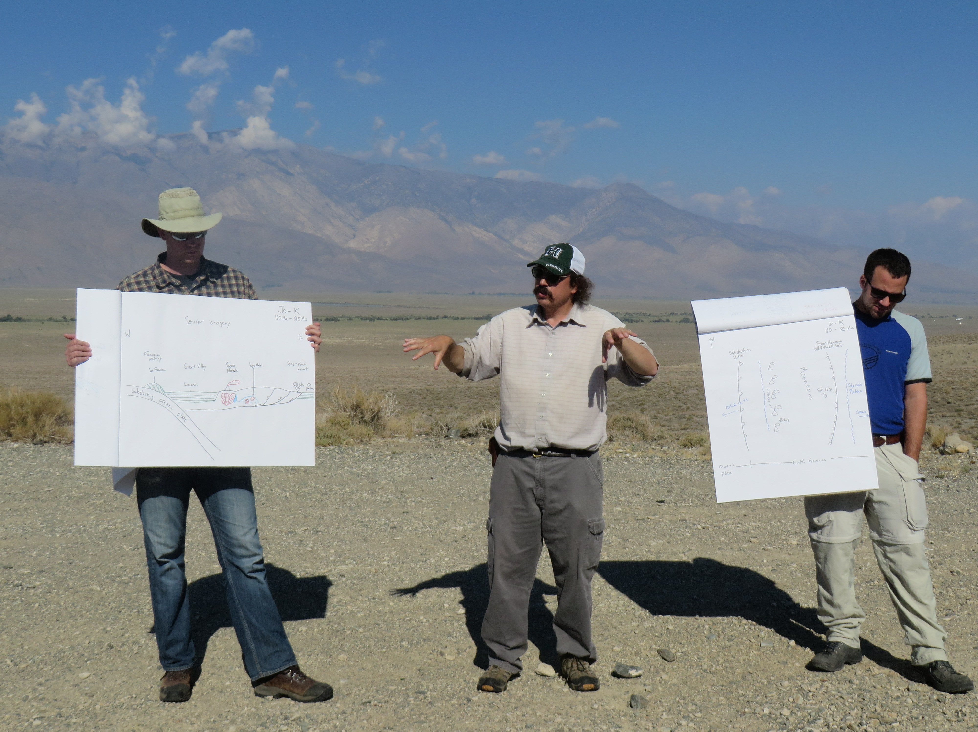

**2013 Research Coordination Networks Awards**

|  |  |  |
| --- | --- | --- |
| **Name & Web Site** | **Project** | **Page** |
| C4P | Collaboration and Cyberinfrastructure for Paleogeosciences | 29 |
| EC3 | Earth-Centered Communication for Cyberinfrastructure: Challenges of Field Data Collection, Management and Integration | 33 |
| SEN | Sediment Experimentalist Network | 39 |

**2014 Research Coordination Networks Awards**

|  |  |  |
| --- | --- | --- |
| **Name & Web Site** | **Project** | **Page** |
| CReSCyNT | Coral REef Science and CYberinfrastructure NeTwork | 31 |
| ECOGEO | EarthCube’s Oceanography and Geobiology Environmental ‘Omics | 35 |
| iSamples | The Internet of Samples in the Earth Sciences | 37 |

http://workspace.earthcube.org/rcns

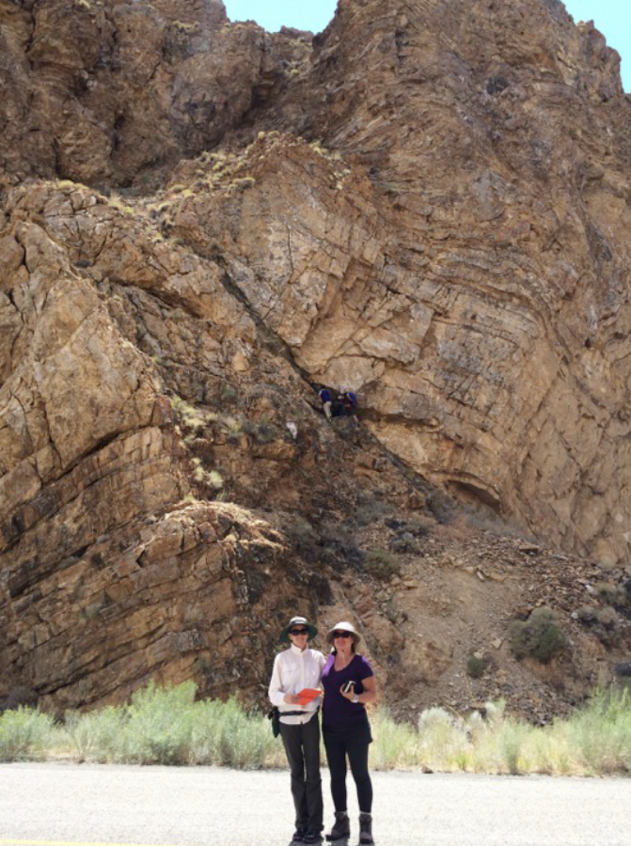

**5.2 Building Blocks: Exploring Solutions and Demonstrating Utility**

EarthCube Building Blocks are created to leverage existing resources that have resulted from investments to date on cyberinfrastructure for geosciences and other sciences.

Building Block projects aim to:

1) **Integrate existing technology components** to extend capabilities to a broader set of geoscientists than are currently served,

2) **Create or modify cyberinfrastructure to overcome shortcomings** identified by the geosciences community, or

3) **Introduce novel cyberinfrastructure** into the geosciences

They are designed to demonstrate utility to geosciences communities within 24 months.

The Building Blocks must articulate how they extend and fit into an overall cyberinfrastructure ecosystem, and how the solution might be broadly applied across all geosciences.

The Building Blocks involve both computer scientists and geoscientists, and often include social and library scientists.

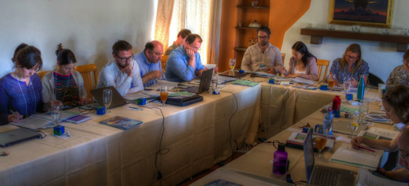

**2013 Building Block Awards**

|  |  |  |
| --- | --- | --- |
| **Name & Web Site** | **Project** | **Page** |
| [BCube](http://workspace.earthcube.org/bcube) | A Broker Framework for Next Generation Geoscience | 45 |
| [CINERGI](http://workspace.earthcube.org/cinergi) | Community Inventory of EarthCube Resources for Geosciences Interoperability | 49 |
| [DisConBB](http://workspace.earthcube.org/discrete-continuous-data-disconbb) | Integrating Discrete and Continuous Data | 55 |
| [Earth System Bridge](http://workspace.earthcube.org/earth-system-bridge) | Earth System Bridge: Spanning Scientific Communities with Interoperable Modeling Frameworks | 59 |
| [GeoDeepDive](http://workspace.earthcube.org/cognitive-computer-infrastructure) | A Cognitive Computer Infrastructure for Geoscience | 63 |
| [GeoSoft](http://workspace.earthcube.org/geosoft) | Collaborative Open Source Software Sharing for the Geosciences | 69 |
| [GeoWS](http://workspace.earthcube.org/geows) | Geoscience Web Services | 71 |
| [ODSIP](http://workspace.earthcube.org/odsip) | An Open Data-Services-Invocation Protocol (ODSIP) | 73 |

**2014 Building Block Awards**

|  |  |  |
| --- | --- | --- |
| **Name & Web Site** | **Project** | **Page** |
| [CHORDS](http://nsf.gov/awardsearch/showAward?AWD_ID=1440133&HistoricalAwards=false) | Cloud-Hosted Real-Time Data Services for the Geosciences | 47 |
| [CyberConnector](http://www.csiss.gmu.edu/cyberconnector) | Bridging the Earth Observations and Earth Science Modeling for Supporting Model Validation, Verification, and Inter-comparison | 51 |
| [Digital Crust](http://workspace.earthcube.org/digital-crust) | An Exploratory Environment for Earth Science Research and Learning | 53 |
| [EarthCollab](http://workspace.earthcube.org/enabling-scientific-collaboration-and-discovery-through-semantic-connections) | Enabling Scientific Collaboration and Discovery through Semantic Connections | 57 |
| [GeoDataspace](http://nsf.gov/awardsearch/showAward?AWD_ID=1440327&HistoricalAwards=false) | Simplifying Data Management for Geoscience Models | 61 |
| [GeoLink](http://workspace.earthcube.org/geolink) | Leveraging Semantics and Linked Data for Data Sharing and Discovery in the Geosciences | 65 |
| [GeoSemantics](http://workspace.earthcube.org/geo-semantic) | A Geo-Semantic Framework for Integrating Long-Tail Data and Models | 67 |

**http://workspace.earthcube.org/building-blocks**

**5.3 Conceptual Designs: Initial Planning for Enterprise Architecture**

EarthCube Conceptual Design projects will generate reports describing an initial enterprise architecture design for EarthCube.

These projects interact with the EarthCube community to understand architecture requirements based on the scope of scientific challenges as well as the existing and planned cyberinfrastructure resources.

The architecture must address:

* The diversity of technologies and infrastructure approaches
* The incorporation of existing systems that are used by geoscientists
* The integration of diverse information in an easy-to-use system
* The dynamic nature of architecture requirements as new research opportunities and innovative technologies arise

The strategy for selecting the EarthCube enterprise architecture will be phased. In the first phase, conceptual designs will be reviewed by the community as the basis for the architecture. The second phase will focus on Design Refinement, where the concept designs will be revised to reflect additional requirements gathered by through ongoing EarthCube activities.

**2013 Conceptual Design Awards**

|  |  |  |
| --- | --- | --- |
| **Name & Web Site** | **Project** | **Page** |
| [DAsHEr](http://workspace.earthcube.org/data-oriented-human-centric) | Developing a Data-Oriented Human-Centric Enterprise Architecture for EarthCube | 79 |
| [GEAR](http://workspace.earthcube.org/transformative-research-collaboration) | Enterprise Architecture for Transformative Research and Collaboration Across the Geosciences | 81 |

**2014 Conceptual Design Awards**

|  |  |  |
| --- | --- | --- |
| **Name & Web Site** | **Project** | **Page** |
| [SC-DA](http://www.nsf.gov/awardsearch/showAward?AWD_ID=1343661&HistoricalAwards=false) | A Scalable Community-Driven Architecture | 83 |

**http://workspace.earthcube.org/conceptual-designs**

**5. 4 EarthCube Test Governance: Formal Mechanisms to Involve the Community**

This project for Test Enterprise Governance outlines an agile model to identify, test and evaluate governance models to manage the development of Geosciences cyberinfrastructure. This model seeks broad engagement and participation of the EarthCube stakeholders to define and assess governance models while seeking evaluation and cross-checks from advisory committees and evaluation mechanisms.  
  
This effort employs an iterative deployment across the range of EarthCube stakeholders to encourage transparency, consensus, and inclusiveness. A broad coalition of stakeholder groups comprise the Assembly and served as a preliminary venue for evaluating and testing governance models in 2012-2013. A Secretariat acted as the coordinating body throughout the first phase of the project, carrying out duties such as planning, organizing, communicating. To ensure broader end-user participation in evaluating governance models, a crowdsourcing approach was used for members not involved in the Assembly.  
  
In 2014-2015, a community-led Demo governance is being tested and improved. The organizational structure will be demonstrated and evaluated. The structure and activities of the Demo governance rely heavily on the outcomes of earlier activities, including 26 end-user workshops. The role of the test governance demonstration is to facilitate community convergence on a reference architecture, procedures for standards, and coordination among emerging EarthCube elements.



**http://workspace.earthcube.org/test-governance**

**6. Getting Involved in EarthCube**

EarthCube is an **evolving, dynamic community effort** that seeks to ensure successful outcomes by actively involving individuals and partners from across the geosciences and cyberinfrastructure sectors. The current phase of EarthCube’s development builds upon the outcomes of the 24 end-user workshops, that incorporate input from ~1500 participants. It also seeks to energetically engage stakeholders whose activities will be furthered and enhanced by the improved access to data and resources that EarthCube’s emerging, community-governed cyberinfrastructure will facilitate.

*You* can become involved and positively impact the future of EarthCube. This is an opportunity for you to influence how data will be collected, accessed, analyzed, visualized, shared, and archived; facilitate and participate in interdisciplinary research; and help educate scientists in the emerging practices of digital scholarship, data and software stewardship, and open science. Collectively these activities will help foster a sustainable future through a better understanding of our complex and changing planet, and enable the geosciences community to develop a framework to understand and predict responses of the Earth as a system—from the space-atmosphere boundary to the core[4].

The demonstration governance structure that resulted from the activities of the Test Governance project is designed to facilitate individual involvement in committees and working groups, and thereby encourage broad representation from across the geoscience community.

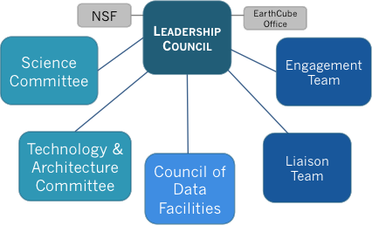High-level structure of EarthCube’s Demonstration Governance.

The components of the demonstration governance represent the diversity of EarthCube functions:

1. **The Science Committee** role is to identify and prioritize end user requirements, and to connect the academic and technology communities. It is co-chaired by Basil Gomez and Emma Aronson and, in the short-term, the work is enabled by three working groups whose tasks are to synthesize: the overarching science drivers identified by the participants of the twenty-four end-user workshops; the funded project’s science goals; and novel use cases.
2. **The Technology & Architecture Committee** role is to test and facilitate technology and architecture development. It is co-chaired by Yolanda Gil and Jay Pearlman, and its work is enabled by working groups whose initial focus is on identifying the technical requirements through science use cases; conducting a funded projects gap analysis; developing testbeds for the funded projects; and the identification of appropriate standards for EarthCube.
3. **The Council of Data Facilities** (CDF) is a federation of existing and emerging geoscience data facilities that serve as a foundation for EarthCube and cyberinfrastructure for the geosciences. The interim chair is Mohan Ramamurthy, and it is co-chaired by Kerstin Lehnert and Don Middleton. The CDF Charter was approved in December 2014. The Council is holding a General Assembly Meeting in January 2015 (after the ESIP Winter Meeting), at which time the members of the Executive Committee (the chair, a vice-chair, a secretary, and four other representatives) will be elected.

1. **The** **Liaison Team** seeks to establish partnerships with existing cyber-initiatives, agencies, associations, and other efforts external to the NSF core constituency, including international activities as well as the private sector. It is co-chaired by Rick Ziegler and Lindsay Powers. The current focus is on mapping the larger geo/CI landscape and community; populating landscape map with organizations, initiatives, agencies, data facilities, *etc.*; and assessing where EarthCube fits into this landscape. The Liaison Team plans to organize a joint session between EarthCube and COOPEUS - (Cooperation EU/US) at the RDA – Research Data Alliance Fifth Plenary Meeting in March 2015.
2. **The Engagement Team** roleis toencourage involvement in EarthCube by proactively reaching out to the geoscience community. The team is chaired by Marjorie Chan. Three working groups are centered around mapping the community engagement scope; conveying new tools and cases; and facilitating internal communication.
3. **The Leadership Council** oversees the activities of the five other components of EarthCube governance, in coordination with NSF as the sponsor and with the EarthCube Office for logistic support. It is presently comprised of community-elected representatives drawn from the Science Committee (Basil Gomez); Technology & Architecture Committee (Yoland Gil); Council of Data Facilities (Mohan Ramamurthy); Liaison Team (Rick Ziegler); and Engagement Team (Marjorie Chan); as well as members at-large of the Cyberinfrastructure (David Actur); Atmosphere/Space (Farzad Kamalabadi); Oceans (Danie Kinkade); Earth Sciences (Kerstin Lehnert); and Polar (unfilled) communities. Basil Gomez is the Leadership Council’s Interim Chair.

The EarthCube Office supports the Leadership Council and all the other governance components, and is part of the Test Governance project.

**The EarthCube Leadership Council**

The Leadership Council is the elected voice of the EarthCube community, setting the strategic direction for EarthCube and making decisions critical to the success of EarthCube with input from the community and in consultation with NSF.

The Leadership Council is formed by representatives of the EarthCube governance components as well as at-large members of the community. Nine voting members include the chair, three standing committee representatives (for the Science Committee, the Technical & Architecture Committee, and the Council of Data Facilities), and five at-large representatives from constituencies of geosciences (one each of Atmosphere, Earth, Oceans, and Polar) and Cyberinfrastructure. Four non-voting members include an Engagement Team Representative, a Liaison Team Representative, a representative from the National Science Foundation, and the Director of the EarthCube Office.

To fulfill this role the Leadership Council will:

• Ensure consistency and transparency in policies, procedures, and decision-making,

including providing multiple ways for people to participate in the process of

making decisions, and communicating outcomes of decisions to the broad

EarthCube community.

• Enable communication between governance organizational units to close gaps,

eliminate duplication, and build synergies.

• Establish and manage Standing Committees and Working Groups as needed to

perform critical functions.

• Foster business models to sustain and maintain the infrastructure of EarthCube.

• Establish, facilitate, and maintain policies and procedures.

• Provide for public dispute resolution and proactive management of risk and

conflicts of interest.

• Act as the single point of communication for coordinating with and making

recommendations to the NSF and other funding agencies on behalf of EarthCube.

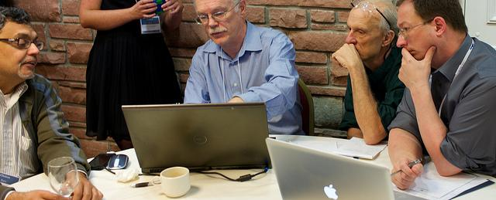All components of the demonstration governance are open to any and all individuals who wish to participate. ***We invite you*** to sign up and share in these activities by visiting the *EarthCube Commons* at <http://workspace.earthcube.org/>.

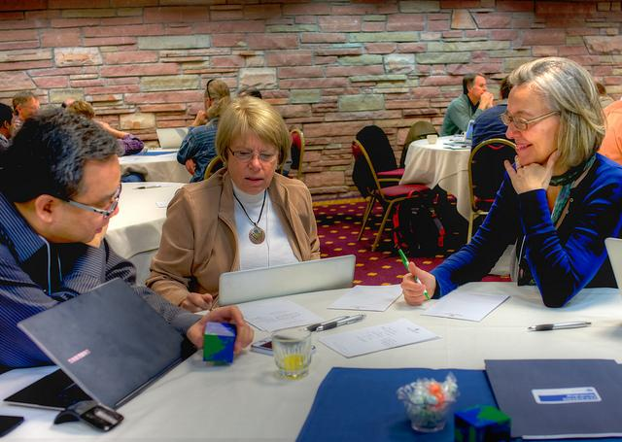**Other Opportunities**

Other major arenas that are open to your participation include:

**1. Professional Meetings**: At the major professional meetings of the geosciences (e.g., AGU - American Geophysical Union, GSA - Geological Society of America, and others), diverse technical sessions and town hall meetings showcase EarthCube activities. Technical sessions permit you to see what projects are in progress and learn about significant results and outcomes. Town hall meetings present thematic information about EarthCube, and offer opportunities for you to raise questions and highlight your concerns. There typically will also be an EarthCube exhibit booth for you to visit, where you can learn about funded EarthCube projects, the new tools that are being developed, and use-case and demonstration science data products.

**2. Workshops:** Future EarthCube activities will encompass science and technology retreats, workshops, training events, and research opportunities. A focus of these activities will be the fostering of interdisciplinary connections and interactions between scientists and technologists. Announcements will be posted on the *EarthCube Commons*, publicized in the bi-weekly community newsletter and communicated to community members by electronic mail.

**3. Research Projects:** The NSF periodically announces proposal opportunities with the object of addressing specific aspects of EarthCube to advance its goals. The more that you know about ongoing EarthCube activities, the more you will understand how to pursue these opportunities.

***EarthCube is a compelling and evolving vision for the geosciences. The more scientists and technologists are engaged, the more EarthCube can achieve.***

***This is your opportunity to help turn ideas into reality!***

To receive EarthCube announcements and other information about the program, you can **subscribe** to the mailing list at <http://workspace.earthcube.org>.

Please **contact us** if you have suggestions or have further questions about how you can be involved: [leadership@earthcube.org](mailto:leadership@earthcube.org).

1. Dear Colleague Letter: <http://1.usa.gov/1BtXS7V>
2. EarthCube Guidance for the Community: <http://1.usa.gov/1wrkkxo>
3. These documents are available in the EarthCube Document Repository: <http://workspace.earthcube.org/document-repository>
4. *Earth Cube Guidance for the Community,*

   NSF11085.